Monday’s Pizza Challenge:
1. Look at picture, what do you notice? Two different combinations on either side of the pizza…..
Your Challenge: Guess the ingredients
Check back In for the Winner
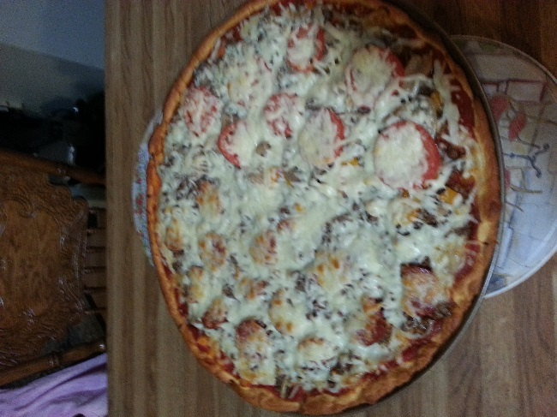

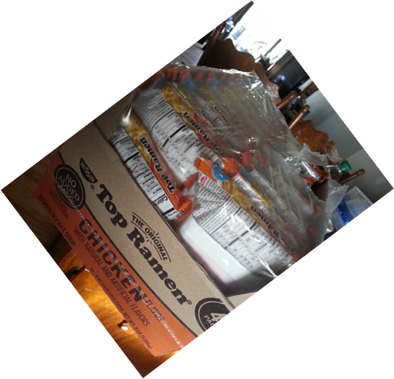
Tuesday’s Challenge: I need help! Give me your best Ramen Noodle recipe and wait for the surprise to see it on our dinner table; yummy

Wednesday’s Feature:
Here is a picture of our succulents, chic’s-n-hens……
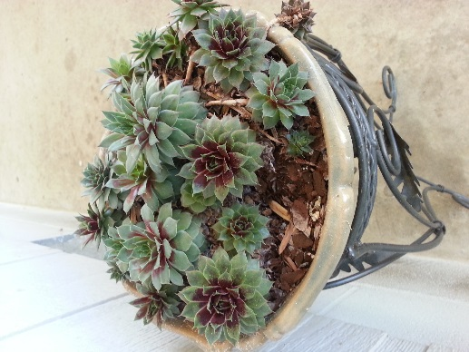
It’s your turn--------please upload a picture of your greenhouse gem of a plant……

